**CRYPT HUNT DOCUMENTATION**

1. Ques : “Carefully observe evrerywhere and then write the answer”

Ans: Answer

1. Ques: That tattoo on your arm.

-.-. / --- / -. / --. / .-. / .- / - / ..- / .-.. / .- / - / .. / --- / -. / ...

Ans: John F Kennedy

The Morse code when translated will yield the answer “Congratulations.” Upon googling congratulations, the user will find number of links. But there is a song named congratulations by Post Malone. “That tattoo on your arm”, is a hint. When they read about Post Malone, they would find he has a tattoo of johnfkennedy.

1. Ques:

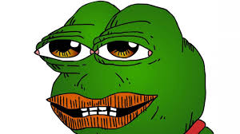

This picture will be there and an audio that says “Thanks”.

Ans: Osmgaming

The audio will just say “Thanks.”. And this picture will be there. They will have to find the youtube video that says thanks and has this frog as the thumbnail. It is a very short 2s video. Once they find this youtube video. They will have to write the channel’s name, i.e., Osmgaming.

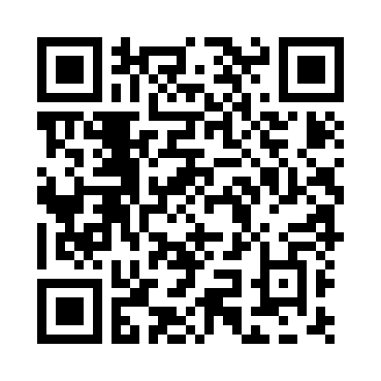

Ans: bees

On scanning the QR code, they will find the sentence.

Dumbells are used by experianced and persevarant fitness freak.

There are spelling errors.

Dumbbells – missing b.

Experienced – missing e

Perseverant- missing e

Freak- missing s

1. ❑︎◆︎♋︎❒︎⧫︎♏︎❒︎ ◻︎♋︎⬧︎⧫︎

Ans: The fall of troy

On solving the windings alphabets, we get “Quarter past”. Its is a song from the fall of troy.

1. 

Ans : Couragueos.

1. 

Ans : james wong howe

1. 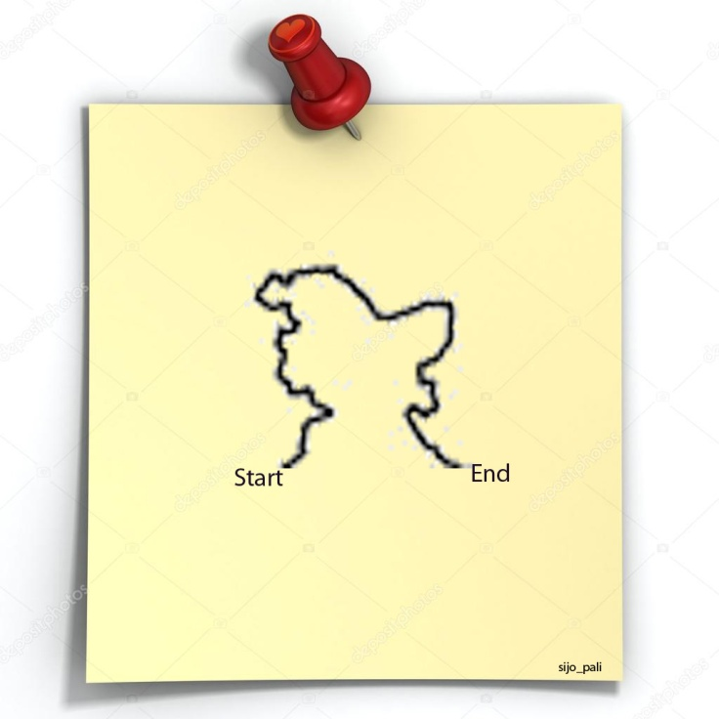

Ans: <https://instagurum.com/media/BYFzwvSnZBI>

1. "We must all try, in every way we can, to send the message that reading is critical to our lives and to the life of our nation."

Ans: George bush virus

1.  CLICK ME

When the user clicks click me she is directed to another page with the pic



Ans: URL

1. The most difficult part of the conundrum was discovered.



Ans: bletchley park

1. "The greatest enemy of knowledge is not ignorance, it is the illusion of knowledge"

Ans: george and the blue moon

1. 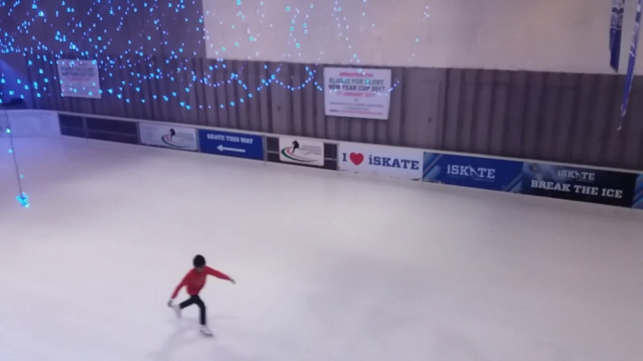

In the beginning…………….Was the command line

Ans: break the code.

1. 

Order for. Order from

Ans : Ofbusiness

1. 

Ans : IGDTUW

1. 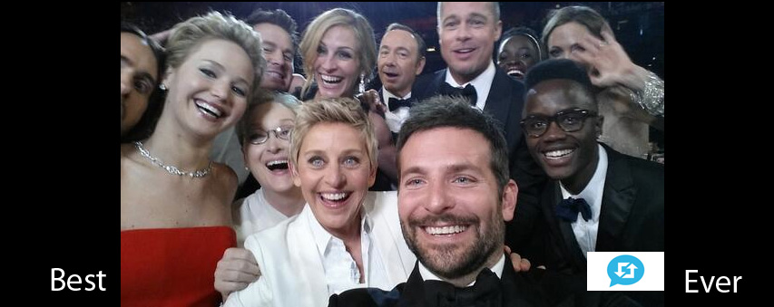

Ans: Bradley’s arm

1. Billions of breeds with sesame seeds.

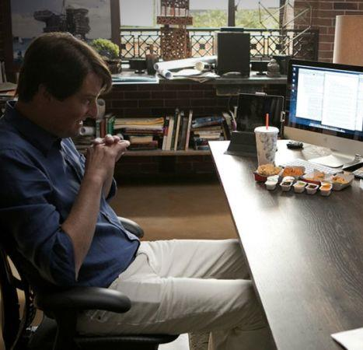

Ans : burger king

1. Ans : NIUE
2. 